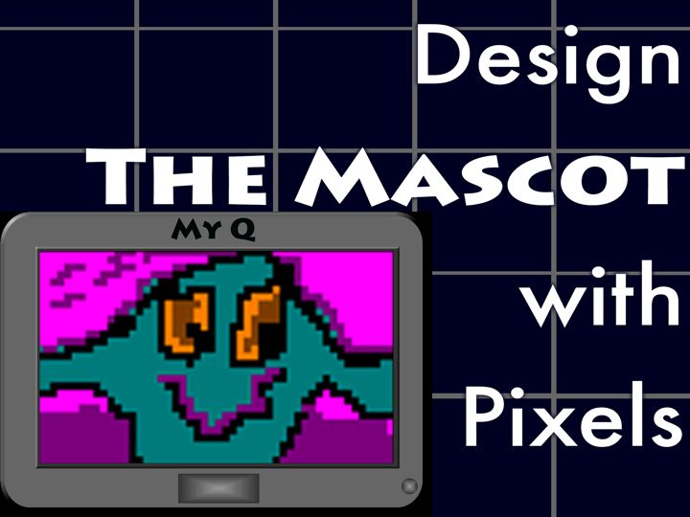
Teacher Notes

Case Overview

In this Case…
- Pupils play the roles of designers of mascots for a new school. The mascot character will reside on a new handheld learning/entertainment device for 5 – 7 year olds – called My Q. You, the teacher, are their supervisor. You have the opportunity to dramatise your role.
- Pupils set design criteria, draw with pixels, estimate area, and resize for different size displays on the device.
- Main mathematics: area as square units; calculating by counting, decomposition and formulae; proportional and non-proportional resizing; changing ratios of sides of rectangles and the effect on area.

Case features

4 lessons with extensions; provides a starter experience with cases.
Pupils are immersed in a design experience.
A set of presentation slides guides lessons; the presentation is a script from which the teacher may improvise.
The teachers’ questions and guidance help make the mathematics more explicit.
There are opportunities for mathematical calculation, reasoning, writing and discussion.
Ideas for extensions include survey design and investigation of tessellations.
Lessons could be shared with a Design teacher.

Materials

Provided: Presentation for Design The Mascot
Pupil handouts
Digital Drawing Tool Flash-based application

Required: Computers, at least one for every 2-3 pupils
Computer with large display or electronic white board for the teacher
Colour pencils or markers, graph paper, calculators
Optional: Examples of characters that appeal to young children
Websites that focus on digital design and use pixels

Key Stage 3 Mathematics Curriculum

This case provides substantial opportunities for pupils to work with enlargements:
Making and using enlargements of 2-D shapes, with positive scale factors — whole numbers and fractions.
Understanding the implications of enlargement for area.
The entire case is an extended exercise in problem solving, communication and reasoning in the area of “shape, space and measures”. Specific skills include
Identifying given information and what further information is needed
Using geometric diagrams to communicate mathematically
Exam papers in the past have included squares and rectangles with the same area and proportional enlargements.

Lesson | Design theme | Mathematics theme
1 | Designing | Decomposing and other area strategies
2 | New Displays | Proportional and non-proportional enlargements — including effects on area.
3 | Simple Shapes | Area approximation.
4 | New Display Formats | Proportional and non-proportional enlargements — including effects on area.

LESSON NOTES
Lesson 1
Slides 1 – 9 | - Get into the spirit of role-play—pupils play designers. You are their supervisor. Read dramatically! Improvise!  - You or your pupils may bring in images of handheld electronic devices or toys with electronic displays—or the actual devices. Examples of handhelds include mobile phones and PDAs. Toys with electronic displays include the Bandai Tamagotchi, the Nintendo Game Boy, the Nintendo DS, and the Sony PSP. Each of these devices displays pixel based art including characters.  - You or your pupils may bring in examples of school mascot designs and graphics.  - Optional: Demonstrate DigiTool to show how pupils will eventually make their design.
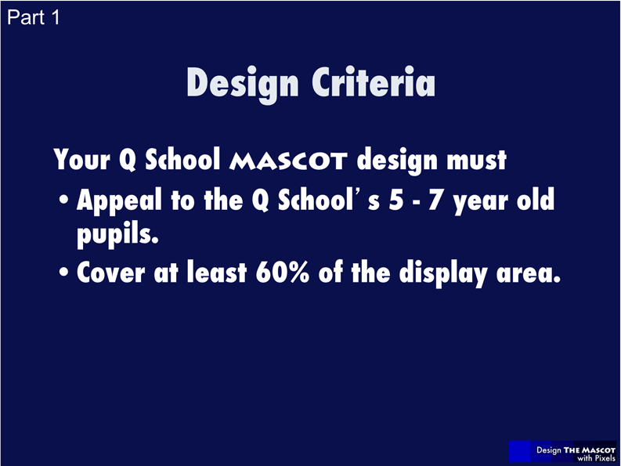  Slides 10 – 11: Part 1 Handout | - Briefly discuss 60%: a bit more than one half.  - Elicit pupils’ knowledge of young children.  - Pupils should respond to the prompts in yellow (see slide 11 for an example).  - Possible criteria: bright colours; big face; like known characters on television.  - Compare two designer responses: different “focal” children lead to different design requirements and ideas.  - Optional: You may tell pupils to use a geometric shape as part of the design, or perhaps that the mascot must cover less than 80% of the screen area as well as more than 60%.
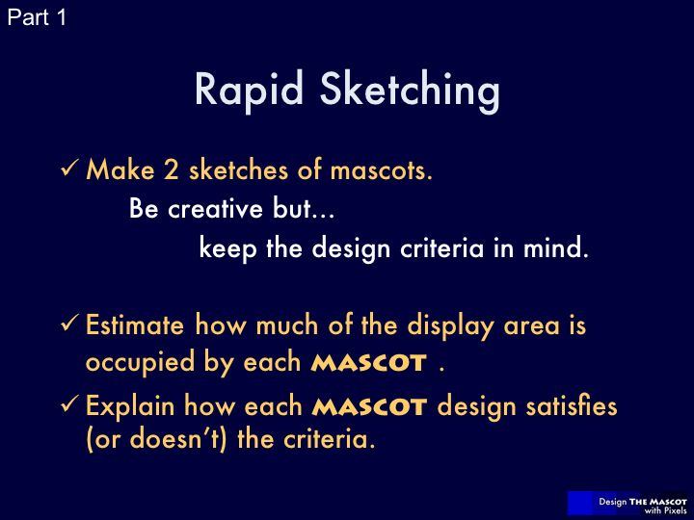  Slide 12: Part 1 Handout | - Pupils use the spaces on the handout, which are the size of the My Q display.  - No grid is provided to encourage freehand drawing and to discourage counting for estimation of area.  - Continue to encourage creativity. Keep the pace rapid: don’t let pupils get bogged down in making “perfect” designs.  - Estimation techniques may rely on pupils de-composing area. Decomposing area is a strategy for solving problems on previous Key Stage 3 exam papers.  - Possible estimation technique (see image below): The four triangles in the centre of the rectangle contain most of the character, but the character is a bit bigger, considering how much of its area is outside the triangles. The four triangles have area equal to 50% of the whole rectangular display. This is because the area of each right angled triangle is half the area of the rectangle in which it is inscribed. Therefore, the character’s area is about 60% of the display.  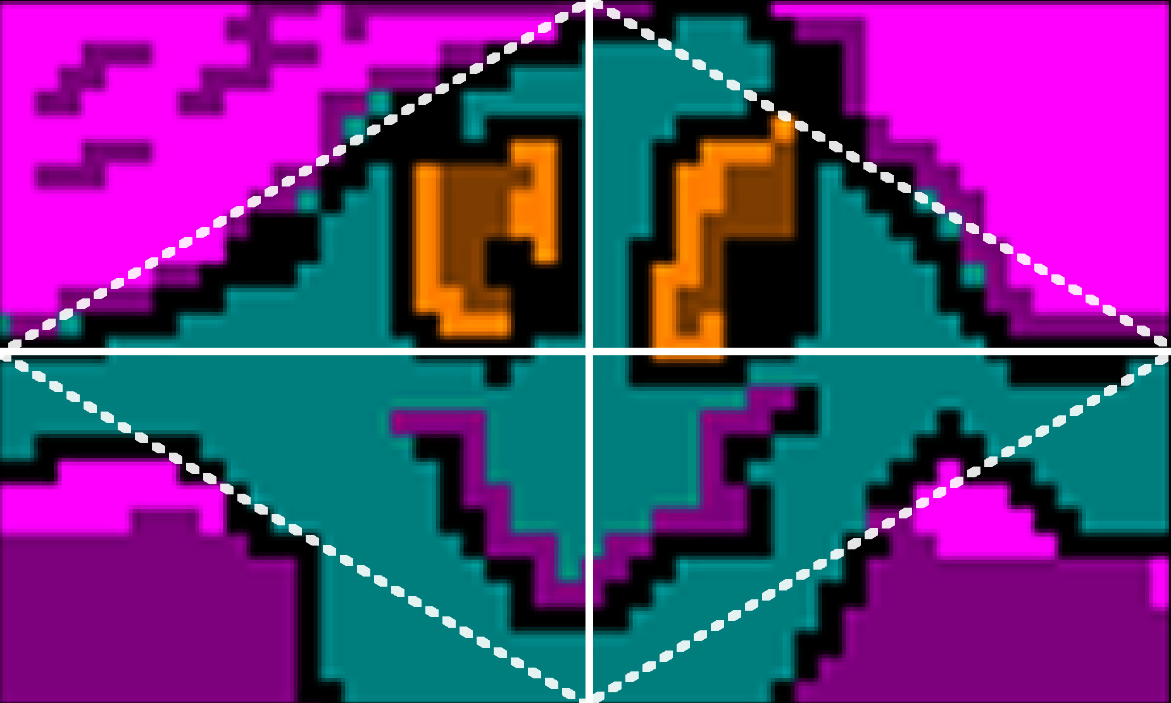
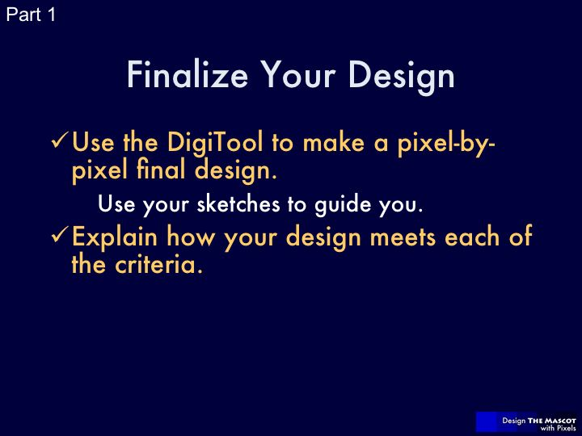  Slide 13: Part 1 Handout | - Pupils use the Digital Drawing Tool to create a final design, using pixels. It should incorporate the best of the two rapid sketches.  - Pupils should, in writing, explain how they know their Mascot takes up at least 60% of the display area.  - Possible methods: The DigiTool grid is 50 by 30 pixels. Now, pixel counting or estimating can be compared with their previous method. Pupils may use knowledge of geometric shape formulae: for example, circles.  - You may review or re-teach concepts or formulae. Finding areas by counting squares is pitched at Level 4 in the National Curriculum.  - Pupils should print or take a screenshot of their Mascot design. They may wish to refer back to this image in the next lesson.
  Slide 14: Class discussion | - This discussion ensures that pupils are exposed to different methods for finding the percentage of the area of the display that is covered by the Mascot.  - The second question is less mathematical in nature, but some pupils may comment on shapes and sizes that are appropriate; look for mathematics as well as design insights.  - Make sure that pupils print or take a screenshot of their Mascot. There is no way to save their design in the DigiTool.

Lesson 2
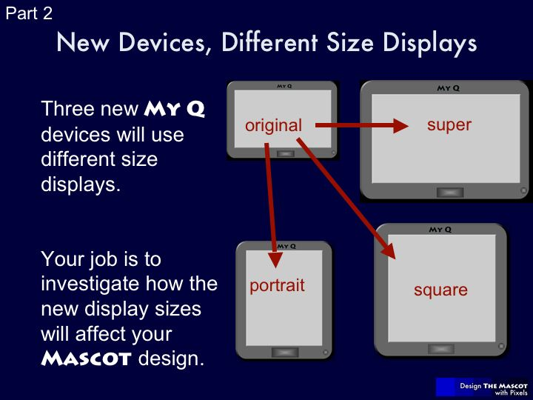  Slide 15-16 | - Have pupils watch the video from slide 15 (this is the second client message)  - As supervisor, make sure that the pupils understand that there are three new proposed models of the My Q device. Ask pupils to describe each one in relation to the others, using mathematics.  - Tell pupils they will investigate the new displays, mathematically, in relation to the original My Q’s display.  - In the end, they may choose any of the new My Qs as best for their Mascot.
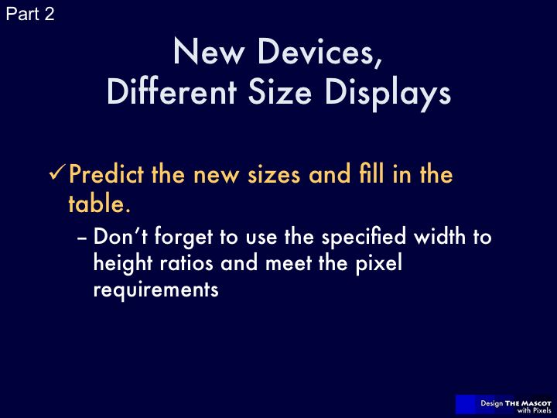  Slide 17: Part 2 Handout | - Pupils use the given information in the table and their knowledge of the current display (50 by 30 pixels) to complete the table.  - The ratio between the sides of the display is often called the “aspect ratio.” There are different conventions for which number comes first in the ratio. We put the width first.  - Displaying an image on a device with a different aspect ratio is commonly accomplished through cropping; otherwise the image may be distorted. For example, showing an image made for regular television (a 4:3 aspect ratio) on a high-definition television (a 16:9 aspect ratio) will either not fill the screen or result in a distorted image.  - Answers will vary in the table, but must meet the constraints. Many pupils will double the dimensions of the given example of the Super My Q, which is much larger than needed but still correct.
  Handheld | width  (in pixels) | height  (in pixels) | ratio of width to height | pixels
  My Q (original) | 50 | 30 | 5:3 | exactly 1500  greater than 3000
  Super My Q | 75 | 45 | 5:3 | 3375
  Square My Q | 39 | 39 | 1:1 | about 1500  1521
  Portrait My Q | 30 | 50 | 3:5 | exactly 1500
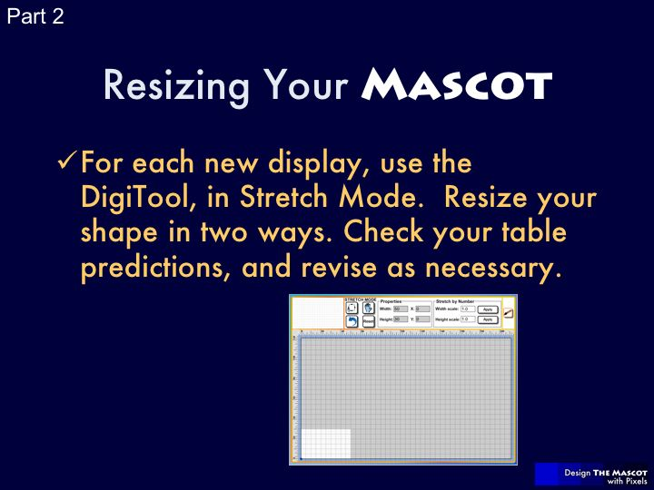  Slide 18 – 19: Part 2 Handout | - Now pupils can test the predictions in their tables using the DigiTool in Stretch Mode. Instead of taking the time to redraw their Mascot, pupils will choose and draw a geometric shape, which they will use for their tests. They may wish to recreate the outline or silhouette of their Mascot. Slide 19 explains how to use the DigiTool in two ways, as asked for in the prompt. Preview the questions they will need to answer by using slides 20 and 21.  - In using the Stretch Mode to resize the display, pupils will:  - Use the Properties mode to test their table numbers. Does the rectangle look like the new display: Portrait, Super or Square? If not, where was the mistake? Revise if needed.  - See the effect of the resizing on their shape: Is it distorted? How? How do they think that their Mascot would look? Would they like the look of the distorted designs? (Some distorted images may be more appealing than the original!)  - Use the stretch mode to investigate the scale factors for resizing, which are not in the table. Ask pupils to make notes on these on their handout. They need to find scale factors that give the same dimensions as in their revised table.  - Observations to invoke:  - They should find that the Super display is an enlargement of the original with the same factor for height and width. This keeps the ratio between the sides as 5:3, as required.  - The other three cannot be re-sized by the same factor for width and height.
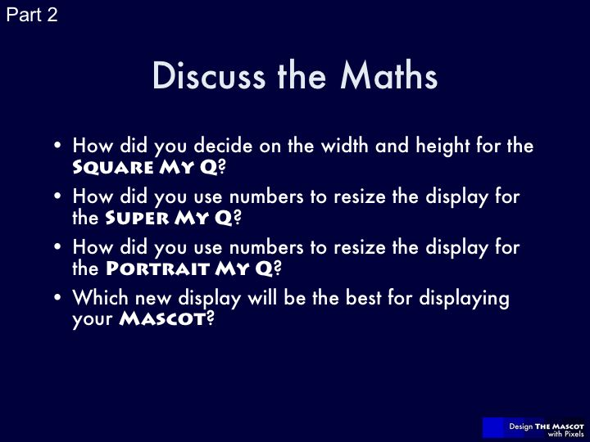  Slide 20: Class Discussion | - The width and height of Square My Q must be the same and the total pixels must be close to 1500, which is not a perfect square. Pupils may begin at 40 (square root of 1600) and test numbers near it until the square is near 1500. Pupils may find that 30 squared is 900 and deduce that their answer should be closer to 40 than 30.  - Introduce or review proportional enlargement, similar figures, and scale factor. Each Super My Q is a proportional enlargement of the original My Q, because the ratio of the sides is still 5:3. Therefore, pupils have to use the same scale factor for width and height.  - The ratios for the original and portrait are inverses: 3:5 and 5:3. The height and width are simply reversed. More advanced pupils may find that the factors for re-sizing to portrait size, 0.6 and 1.666…, are multiplicative inverses.
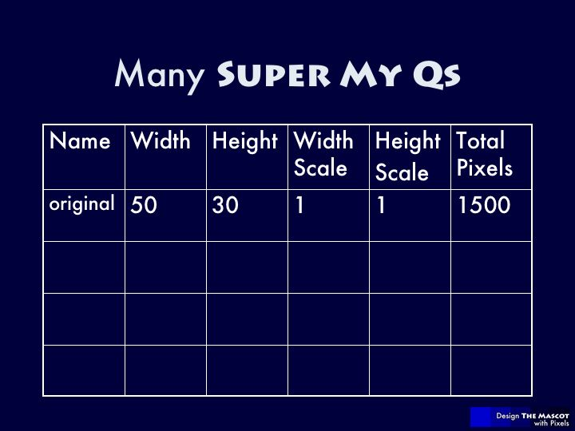  Slide 21: Class Discussion | - Fill in this table, using different pupils’ Super My Q answers. Choose those with greatly different scale factors. Choose a fractional scale factor if possible.
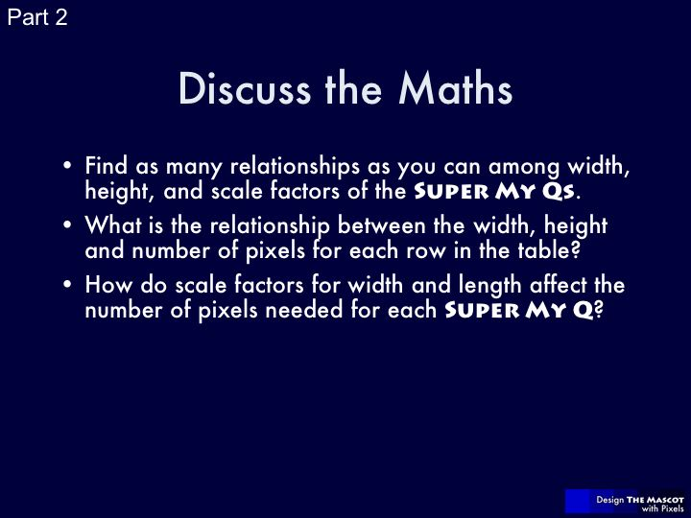  Slide 22: Class Discussion | - Relationships in the table:  - The width and height are always in ratio 5:3. Because of this, the scale factor for width and height is always the same, but there are different scales for different Super My Qs.  - The larger the scale factor, the larger the width and height.  - Scale factors need not be whole numbers. If no pupil has done so, try a scale factor of 1.5, which gets close to the area of 3000.  - The number of pixels that make up the whole design is just the area of the display, expressed in pixels.  - For Super My Qs with a scale factor of 2, the area is increased by a factor of 4.  - Elicit the general principle that if a rectangle is enlarged by a factor of n, the area is increased by a factor of n².  - Optional extension: Investigate the effect of scale factors on area for Square My Q as compared to the original.

Lesson 3
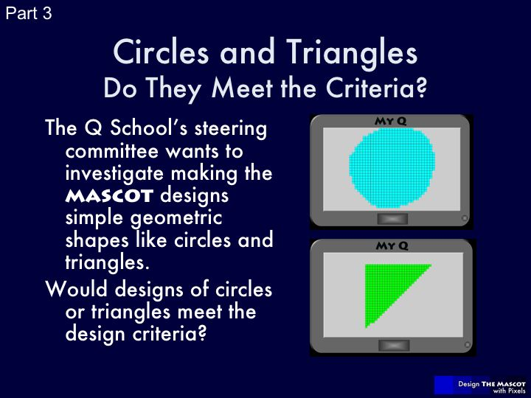  Slide 23-24 | - Have pupils watch the video from slide 23 (this is the third client message).  - As supervisor, make sure that the pupils understand that the proposal is to use only circle or triangle-shaped mascots.  - The pupils will investigate mathematically whether circle or triangle-shaped mascots meet the design criterion of covering 60% of the display area.  - Encourage the pupils to justify their answers.
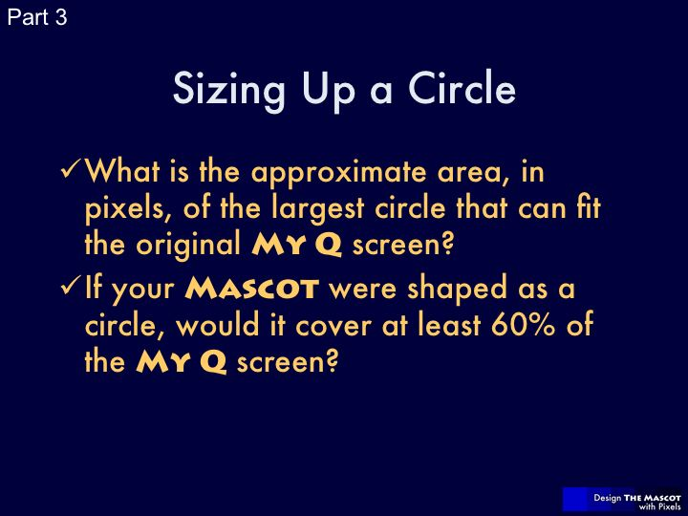  Slide 25: Part 3 Handout | - Pupils work through the same exercise for both the circle and the triangle.  - A typical pupil work process may be:  - Determine maximum dimensions of the shape (for example, 30 pixel diameter for the circle);  - Calculate the shape’s area using the maximum dimensions;  - Calculate the shape’s area as a percentage of the display area.
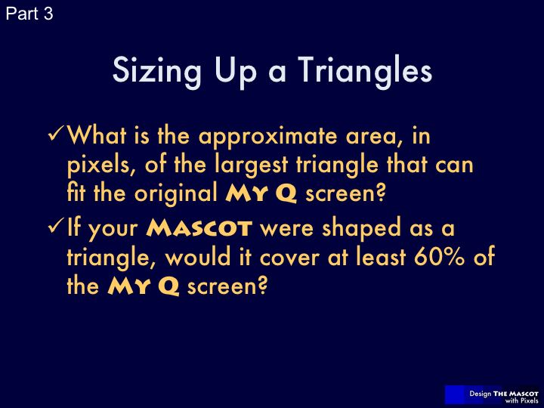  Slide 26: Part 3 Handout | - For triangles, working out the maximum area may require consideration of various kinds of triangles.  - Here is one way to answer: One way to maximize the area of a triangle is to have two of its vertices the same as two of the vertices of the rectangle (see below for examples). Consider, for example, a right angled triangle that “cuts” the display in half with its hypotenuse. Its area is 50% of the rectangle’s area. Any other maximal triangle will have the same area, with heights of 30 and widths of 50, like the displays. Therefore, the most area that a triangle can “occupy” is 50% of the display.  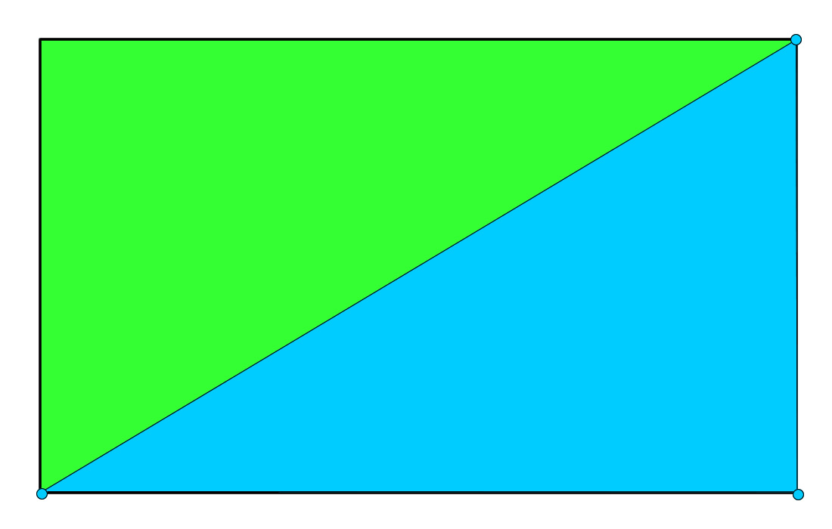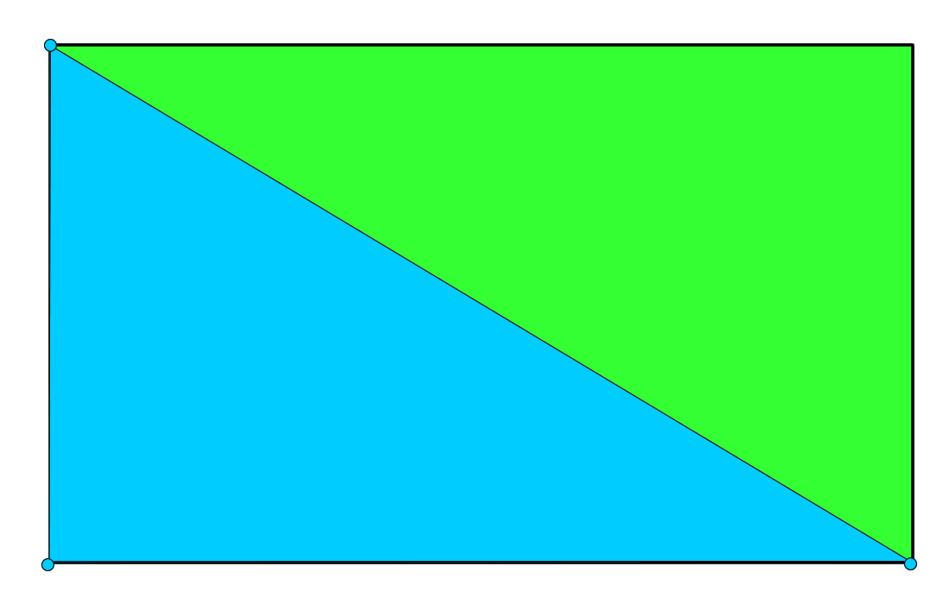  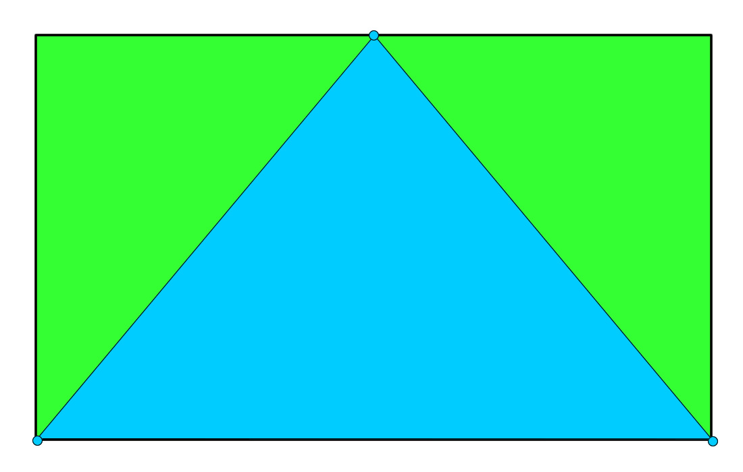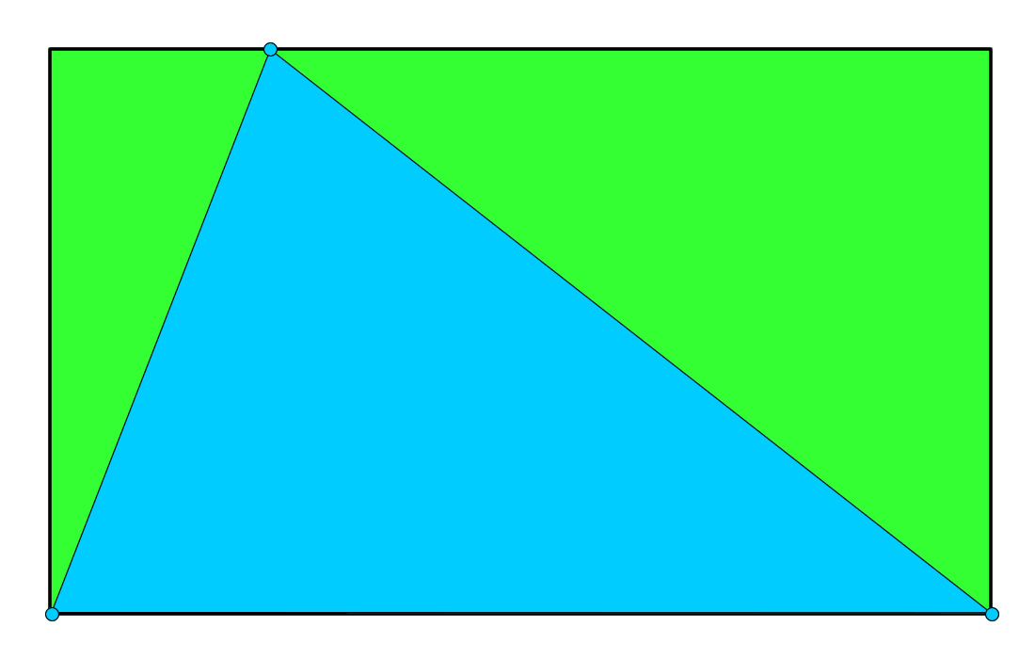
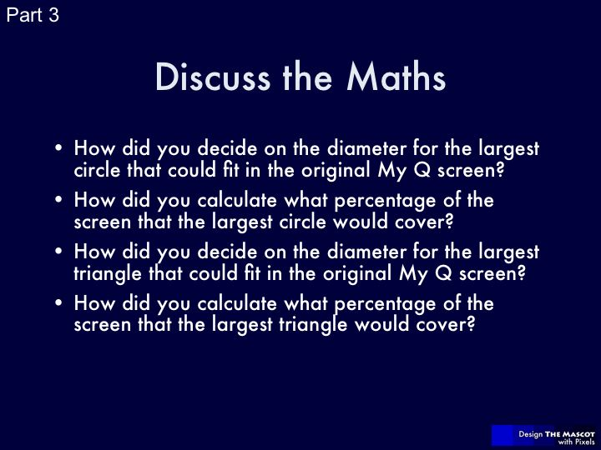  Slide 27: Class Discussion | - Discuss the process the pupils used to answer the questions on their handouts.  - Make sure pupils justify their answers, and check for understanding.

Lesson 4
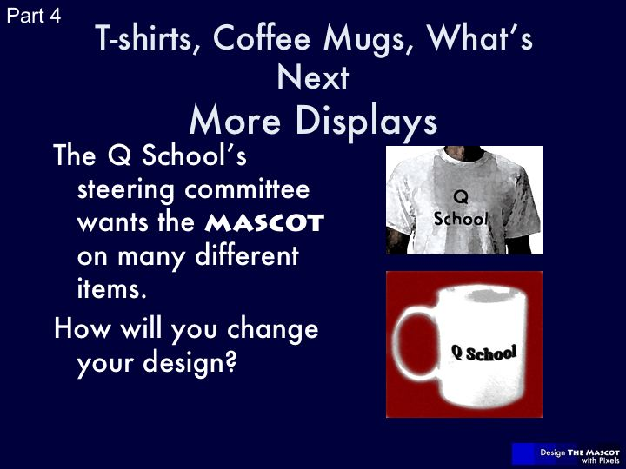  Slide 28-29 | - Have pupils watch the video from slide 28 (this is the fourth client message).  - As supervisor, make sure that the pupils understand that the proposal is to put their Mascot designs on other objects like t-shirts and coffee mugs.  - This activity is similar to the activity in part 2. Pupils investigate the revisions necessary for their mascots to meet the design criterion of covering 60% of the new display areas.  - Encourage the pupils to justify their answers.  - Pupils use the given information in the table and their knowledge of the current display (50 by 30 pixels) to complete the table.  - As in Part 2, instead of taking the time to redraw their Mascot, pupils will choose and draw a geometric shape which they will use for their tests. They may wish to recreate the outline or silhouette of their Mascot.  - In using the Stretch Mode to resize the display, pupils will:  - Use the Properties mode to test their table numbers. Does the rectangle look like the display area of the t-shirt / coffee mug? If not, where was the mistake? Revise if needed.  - See the effect of the resizing on their shape: Is it distorted? How? How do they think that their Mascot would look? Would they like the look of the distorted design?  - Observations to invoke:  - Pupils should find that the t-shirt display is not an aspect ratio that they have previously encountered.  - Pupils may recognize that the aspect ratio of the coffee mug matches that of the Portrait My Q.
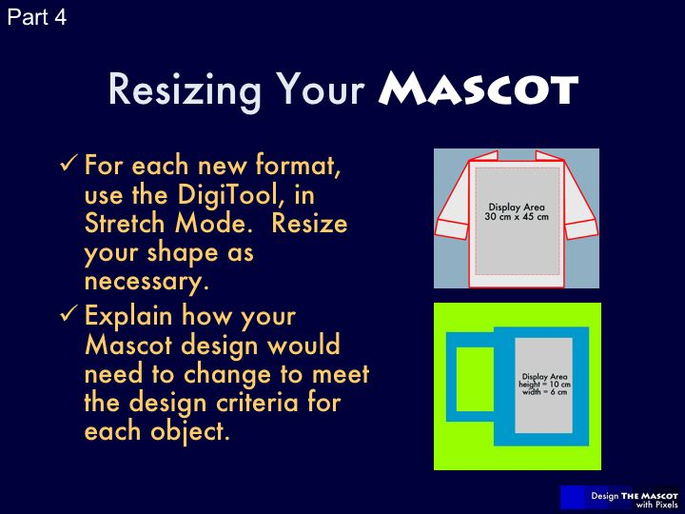
Slide 30: Part 4 Handout
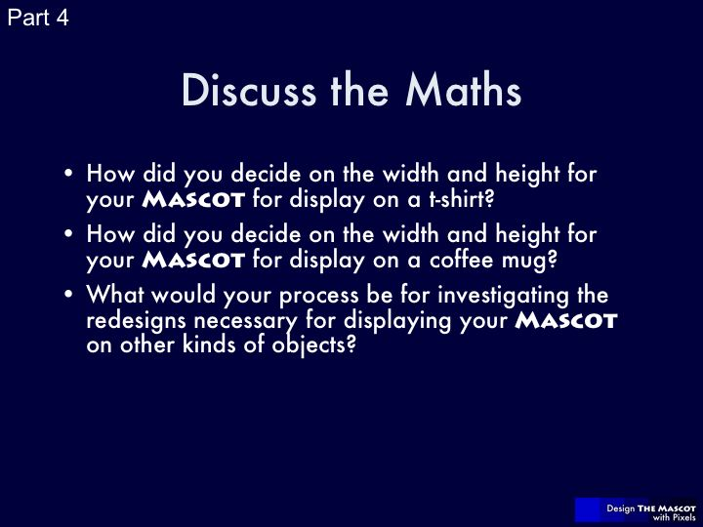  Slide 31: Class Discussion | - Discuss the process the pupils used to answer the questions on their handouts.  - Make sure pupils justify their answers, and check for understanding.
  Slide 32: Class Discussion | - This is your last opportunity to play supervisor. Thank pupils for a job well done and choose particular strengths to note: a wide variety of designs, astute mathematical observations. You may ask pupils to state some project work of which they are particularly proud.  - Pupils may discuss photo manipulation software and scale drawings. You can add that digital graphics work is, in fact, a growing field for real careers.
Ideas for Extensions | - Part 1: Pupils could design, conduct, and analyze a survey of 5-7 year olds to identify their visual design preferences (shapes, colours, etc.).  - Part 2: Investigate the effect of scale factors on area for Square My Q as compared with the original.  - Part 3: Pupils investigate use of circle-shaped mascots with rectangular displays with various aspect ratios and determine whether a circle-shaped mascot could ever meet the design criterion of covering 60% of a rectangular display area. Pupils could also find the aspect ratio that would result in an area coverage of approximately 60%.  - Part 4: Pupils could investigate the use of tessellations to solve design problems including the use of mascot design for irregularly shaped objects (for example, an archway) or objects with more extreme width to height ratios, such as scarves.  - Part 4: Pupils could use t-shirt and product customization websites such as zazzle.com or cafepress.co.uk to translate their designs into real objects.

